Additional materials:
Appendix A: Hyperparameter Setting and Rationale
To ensure the reproducibility and optimal performance of the proposed method, the key hyperparameters were carefully determined through a combination of established best practices in reinforcement learning literature and preliminary empirical grid-searches on a subset of training instances.
GAT Architecture Parameters: The depth and width of the Graph Attention Network are pivotal for capturing the topological structure of the scheduling environment. Through preliminary testing, the number of GAT layers was set to 2. This allows the nodes to aggregate sufficient multi-hop neighborhood information (i.e., capturing the state of preceding and succeeding operations as well as competing machines) while strictly preventing the "over-smoothing" phenomenon, which degrades state representation distinctiveness in deeper GNNs. Additionally, the number of attention heads was set to 4 for both the operation and machine attention blocks to ensure stable self-attention learning and diverse feature representation without incurring excessive computational overhead.
PPO Optimization Parameters: The PPO clipping parameter strictly defines the trust region for policy updates. We adopted the widely recommended value of 0.2, which empirically provided the most stable monotonic convergence during the pre-training phase by preventing destructively large policy step sizes in the highly stochastic job shop state space. Furthermore, the smoothing coefficient for GAE controls the bias-variance trade-off of the reward signal. A preliminary sensitivity analysis indicated that setting to 0.98 optimally balances the impact of long-term delayed rewards and short-term immediate rewards, ensuring that the critic network provides reliable baseline evaluations for the actor network.
Appendix B: Discussion on the Decoupled Learning Paradigm and Intra-task Preference Transfer
Although integrating DRL with multi-objective preferences has been explored in continuous control tasks, its direct application to highly constrained discrete optimization problems, such as the MOFJSP, remains challenging. Unlike existing preference-conditioned DRL approaches that attempt to train a universal multi-objective policy from scratch—which frequently suffer from severe gradient interference between learning complex physical scheduling rules and shifting target preferences—the proposed P-DRL framework introduces a novel decoupled learning paradigm. By isolating preference-agnostic topological learning (baseline pre-training) from preference-specific adaptation (fine-tuning), our method fundamentally circumvents gradient conflicts, ensuring highly stable convergence within large-scale state spaces.
Furthermore, it is crucial to distinguish our baseline-finetuning mechanism from conventional transfer learning. Standard transfer learning in scheduling primarily focuses on domain adaptation (e.g., transferring a policy trained on small-scale instances to large-scale environments). In contrast, our method introduces an Intra-task Preference Transfer. We reconceptualize the fine-tuning mechanism not as an environmental adapter, but as a highly efficient Pareto front constructor. By anchoring on a Pareto-centric baseline model, rapid few-shot fine-tuning is deployed to delineate extreme and intermediate points along the Pareto front with exceptional time efficiency. This uniquely positions our fine-tuning strategy as a dedicated multi-objective optimization mechanism, transforming DRL from a conventional single-point solver into a practical, high-resolution Pareto-set generator for real-time manufacturing systems.
Appendix C：flowchart and pseudocode
Table 3. pseudocode
Algorithm 1: Two-Stage Preference-Driven Graph Reinforcement Learning (P-DRL)
Input: MOFJSP with initial parameters , training instances, testing instances,Pre-training epochs
Output: Multi-objective policy library and Pareto optimal schedules for
Phase 1: Preference-Agnostic Base Pre-training (Offline)
1: Initialize Actor network and Critic network with random parameters
2: For to do
3: Sample a batch of instances from
4: While environment not terminated do
5: Extract global topological feature via Actor GAT encoder
6: Sample action and execute in environment
7: Receive nonlinear net efficiency reward (Eq.12)
8: End While
9: Compute GAE using Critic and
10: Update Actor and Critic by maximizing the PPO objective (Eq.21)
11: End For
12: Save converged parameters as the Pareto Base Model:
Phase 2: Preference-Driven Fine-tuning for Policy Library (Offline)
13: Initialize an empty Multi-Objective Policy Library
14: For each preference weight vector do
15: Restore networks from Base Model:
16: For to GWN do
17: Sample instances from and fuse condition into the state
18: Collect trajectories and compute the scalarized targeted reward (Eq.13)
19: Update Actor and Critic by maximizing the PPO objective
20: End For
21: Save the specialized model and add to Library:
22: End For
Phase 3: Millisecond-level Online Inference (Online)
23: Receive an unseen instance from , initialize Pareto set
24: For each specialized policy (executed in parallel) do
25: Execute greedy forward inference without gradient updates to obtain schedule
26: Evaluate objective values and add to
27: End For
28: Return non-dominated solutions fromas the final Pareto Front.
Fig. 4. flowchart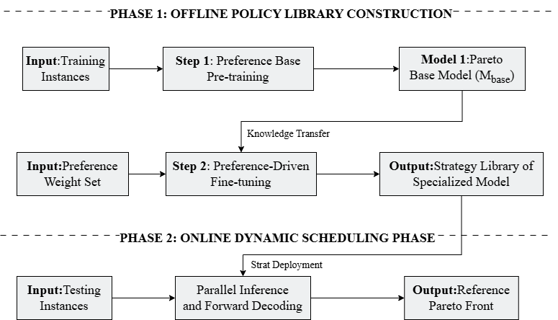
Appendix D：Computational Efficiency and Real-Time Applicability
Table 4. Comparison results of P-DRL with the other methods
Size | Method |  | IGD (Mean ± Std) Test | HV (Mean ± Std) Test
10×5 | GR-WCDR | 83.81 | 0.9484±0.0000 + | 0.1053±0.0000 +
 | GA | 372.21 | 0.2932±0.0442 + | 0.6817±0.0522 +
 | NSGA-II | 417.62 | 0.1622±0.0781 + | 0.6741±0.0497 +
 | P-DRL | 20.55 | 0.2783±0.0012 | 0.8892±0.0079
15×10 | GR-WCDR | 125.65 | 0.8917±0.0000 + | 0.0971±0.0000 +
 | GA | 448.95 | 0.3186±0.0719 + | 0.2862±0.0686 +
 | NSGA-II | 481.53 | 0.2419±0.0475 + | 0.6273±0.0551 +
 | P-DRL | 45.68 | 0.2327±0.0017 | 0.8919±0.0046
20×5 | GR-WCDR | 187.19 | 1.0249±0.0000 + | 0.0796±0.0000 +
 | GA | 634.54 | 0.3187±0.0488 + | 0.4211±0.0710 +
 | NSGA-II | 689.84 | 0.2894±0.0612 + | 0.4937±0.0802 +
 | P-DRL | 82.71 | 0.1898±0.0062 | 0.9122±0.0038
30×10 | GR-WCDR | 380.56 | 1.1834±0.0000 + | 0.1055±0.0000 +
 | GA | 1065.53 | 0.5273±0.0846 + | 0.2911±0.0910 +
 | NSGA-II | 1183.26 | 0.4922±0.0794 + | 0.4098±0.0856 +
 | P-DRL | 138.63 | 0.3408±0.0027 | 0.9531±0.0042
To rigorously validate the practical applicability of the proposed P-DRL framework in real-world manufacturing environments, an analysis of its computational efficiency is imperative. In dynamic job shops, stochastic events such as machine breakdowns or rush order arrivals demand immediate rescheduling. Algorithms hampered by prolonged computational latency are fundamentally unsuited for such real-time execution.
Table 4 details the comparative computational times and algorithmic performance. To ensure a standardized evaluation, the traditional meta-heuristic baselines (GA and NSGA-II) were constrained to a minimal search budget, specifically a population size of 50 and 20 generations.
As illustrated in Table 4, the traditional baselines incur prohibitive computational overhead as the problem scale expands. For the instances, NSGA-II requires 1183.26 seconds merely to execute 20 generations—a budget generally insufficient for multi-objective convergence. Conversely, P-DRL fundamentally circumvents the online iterative search phase. By leveraging the pre-trained conditioned policy for parallel forward inference, P-DRL processes the entire batch in a mere 138.63 seconds.
Notably, despite requiring nearly an order of magnitude less computational time, P-DRL consistently yields significantly higher Hypervolume (HV) and superior IGD metrics across medium-to-large scale instances (e.g.,). This substantial computational acceleration, paired with exceptional solution quality, robustly satisfies the stringent, sub-minute decision windows characteristic of modern industrial control systems, thereby confirming the viability of P-DRL for real-time dynamic scheduling.
Appendix E: Efficacy of the Preference Input Mechanism
To rigorously validate the efficacy of the proposed preference input mechanism, it is imperative to ascertain whether the P-DRL agent dynamically adjusts its scheduling policy in response to shifting input weights. As illustrated in the Pareto front scatter plots (Figure 3), the 11 distinct solutions generated by P-DRL are strictly dictated by the predefined preference vectors . Using the instance as a representative example, when the preference is heavily skewed toward production efficiency (), the agent learns to greedily allocate parallel machines to minimize cycle time, thereby yielding the lowest makespan but incurring the highest energy consumption. Conversely, as monotonically decreases to 0.0 (with proportionally increasing to 1.0), the agent progressively adapts its strategy to penalize high-power machinery and minimize idle times. This behavioral shift results in a strictly monotonic decrease in total energy consumption accompanied by a corresponding monotonic increase in makespan. This highly sensitive, monotonic mapping between the input preference conditions and the resultant objective values robustly demonstrates that the conditioned policy has successfully internalized the underlying trade-off dynamics, thereby substantiating the effectiveness of the preference-guided fine-tuning mechanism.

